Terraform Notes

Install Terraform on AWS ec2 instance:
sudo apt-get update && sudo apt-get install -y gnupg software-properties-common

wget -O- https://apt.releases.hashicorp.com/gpg | \
gpg --dearmor | \
sudo tee /usr/share/keyrings/hashicorp-archive-keyring.gpg

gpg --no-default-keyring \
--keyring /usr/share/keyrings/hashicorp-archive-keyring.gpg \
--fingerprint

echo "deb [signed-by=/usr/share/keyrings/hashicorp-archive-keyring.gpg] \
https://apt.releases.hashicorp.com $(lsb_release -cs) main" | \
sudo tee /etc/apt/sources.list.d/hashicorp.list

sudo apt update
sudo apt-get install terraform

Now Make Directory:
mkdir devops
cd devops
sudo vim local.tf

local.tf file content to create txt file (HCL language) HashiCorp Configuration language:
resource "local_file" "devops"{
filename = "/home/ubuntu/terraform/devops_automated.txt"
content = "I want to become a DevOps Engineer"
}

Now save it.
Now initialised Terraform: terraform init
Check your local.tf file: terraform validate
Check Terraform plan: terraform plan
Apply all the things: terraform apply

Generate Randorm String using terraform:
code:
resource "random_string" "rand-str" {
length = 16
special = true
override_special = "!#$%&*()-_=+[]{}<>:?"

}

To Generate output:
code:
output "rand-str" {
value = random_string.rand-str[*].result
}

if you used another resource provider then you have to re initialized terraform using:
terraform init > terraform validate > terraform plan > terraform apply

Install Nginx using docker by using terraform:
First step:
install docker: sudo apt-get install docker.io
sudo docker ps
Now giver permission to terraform (Because terraform not use “sudo” when using docker)
sudo chown $USER /var/run/docker.sock

Now create one folder then one file:
mkdir terraform-docker
Cd terraform-docker
Sudo vim main.tf
Code:
terraform {
required_providers {
docker = {
source = "kreuzwerker/docker"
version = "3.6.2"
}
}
}

provider "docker" {}

resource "docker_image" "nginx" {
name = "nginx:latest"
keep_locally = false
}

resource "docker_container" "nginx" {
image = docker_image.nginx.image_id
name = "nginx-tf"

ports {
internal = 80
external = 80
}
}

Variables in Terraform :
If you want to explicitly give variable name like this then use TF_VAR_<Path_name> like that:
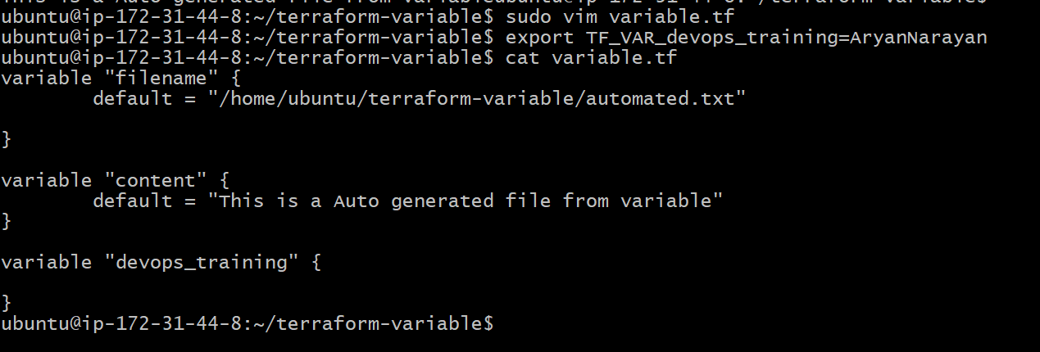

Create EC2 instance through Terraform:
First you need to install AWS CLI in your vm
To check weather AWS CLI install or not: aws s3 ls

To install AWS cli: sudo apt install awscli

Now configure your terminal with AWS access key:
Command: aws configure
Now give access key:
Now give access secret key:

Now give permission to terraform to use aws:
export AWS_ACCESS_KEY_ID=<access key>
export AWS_SECRET_ACCESS_KEY=<secret access key>

Now create one .tf file: main.tf
Code for basic creation of aws:
code:
terraform {
required_providers {
aws = {
source = "hashicorp/aws"
version = "6.19.0"
}
}
required_version = ">= 1.2.0"

}

provider "aws" {
region = "ap-south-1"
}

resource "aws_instance" "my_ec2_instance" {
count = 2
ami = "ami-02b8269d5e85954ef"
instance_type = "t3.micro"
tags = {
Name = "ETP_Instance"
}
}
output "ec2_public_ips" {
value = aws_instance.my_ec2_instance[*].public_ip
}

Creation of aws ec2 and s3 both in one file:

terraform {
required_providers {
aws = {
source = "hashicorp/aws"
version = "6.19.0"
}
}
required_version = ">= 1.2.0"

}

provider "aws" {
region = "ap-south-1"
}

resource "aws_instance" "my_ec2_instance" {
count = 5
ami = "ami-02b8269d5e85954ef"
instance_type = "t3.micro"
tags = {
Name = "lpukart-Instance"
}
}

resource "aws_s3_bucket" "my_s3_bucket" {
bucket = "terraform-aryan-12"
tags = {
Name = "terraform-aryan-12"
Environment = "Dev"
}
}

output "ec2_public_ips" {
value = aws_instance.my_ec2_instance[*].public_ip
}

